


CALCULATING FAMILY EXPENSCES USING
SERVICENOW

TEAM ID: LTVIP2026TMIDS60355

TEAM MEMBERS: 4
`
TEAM LEADER: Mallipudi Meher Lakshmi Priya

TEAM MEMBER 1: Pentapati Vishnu Ratha

TEAM MEMBER 2: Gavarasani Sivadurga

TEAM MEMBER 3: Pusarla Sri Divya

TASK INITATION

Setting up ServiceNow Instance
- Sign up for a developer account on the ServiceNow Developer site “https://developer.servicenow.com”.
- Once logged in, navigate to the "Personal Developer Instance" section.
- Click on "Request Instance" to create a new ServiceNow instance.
- Fill out the required information and submit the request.
- You'll receive an email with the instance details once it's ready.
- Log in to your ServiceNow instance using the provided credentials.
- Now you will navigate to the ServiceNow.
Creation of New Update Set
- Go to All >> In the filter search for Local Update set > click on New.
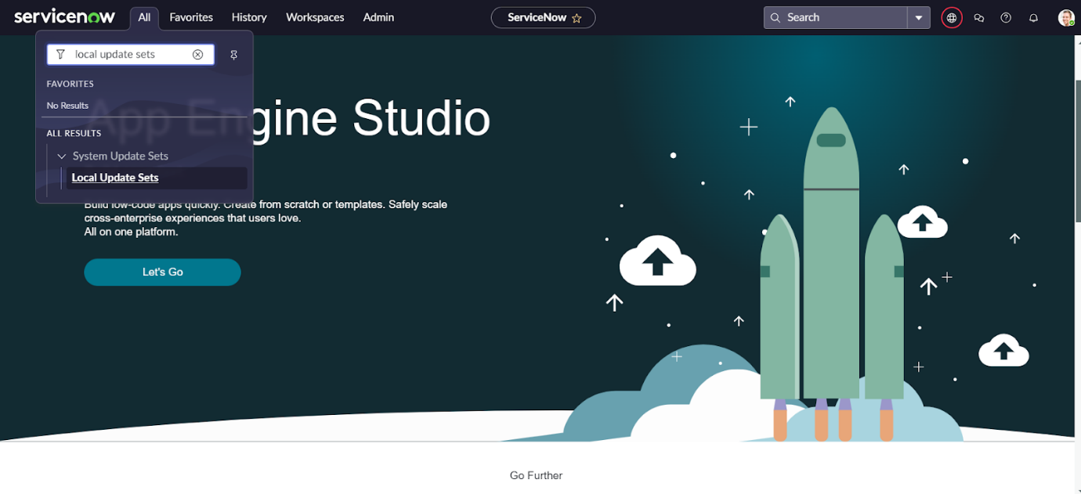
- Enter the Details as:
Name: Family Expenses
- Then click on Submit and Make current.
Creation of Family Expenses Table
- Go to All > In the filter search for Tables > click on New.
- Enter the Details:
Label: Family Expenses
Name: Auto-Populated
New menu name: Family Expenditure
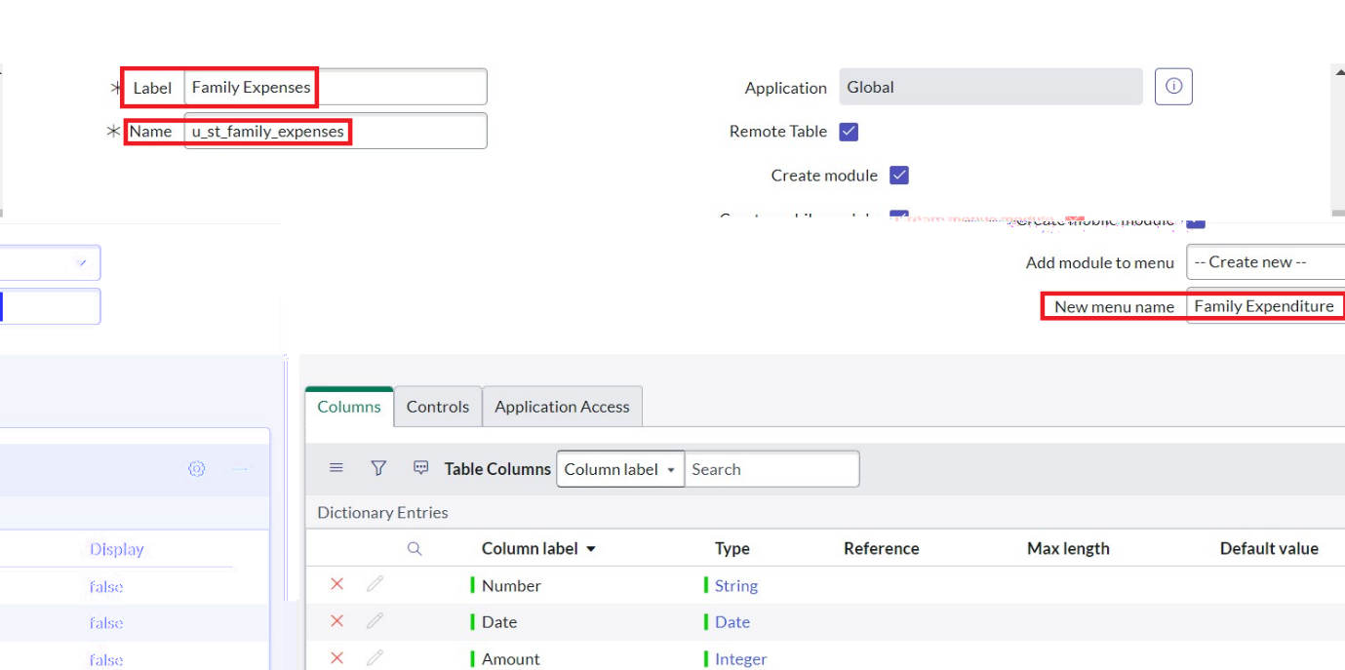
- Go to the Header and right click there>> click on Save.

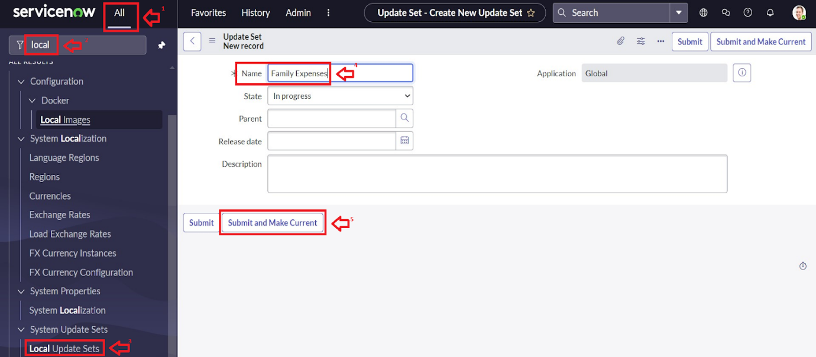

Creation of Columns(Fields)
- Near Columns Double click near insert a new row.
- Give the details as:
Column label : Number
Type : String
- Double click on insert a new row again
- Give the details as:
Column label : Date
Type : Date
- Double click on insert a new row again
- Give the details as:
Column label : Amount
Type : Integer
- Double click on insert a new row again
- Give the details as:
Column label : Expense Details
Type : String
Max length : 800
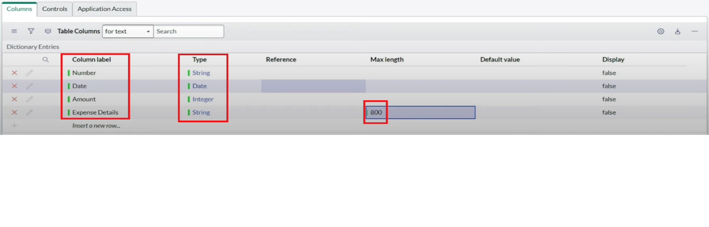
- Go to the Header and right click there>> click on Save.
Making Number Field an Auto-Number
- Double click on the Number Field/Column.
- Go down and double click on Advanced view
- In Default Value:
Use dynamic default : check the box
Dynamic default value : Get Next Padded Number
- Click on Update.
- 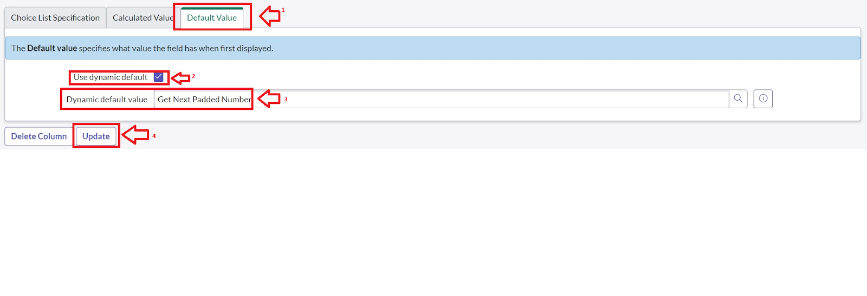
- Go to All >> In the filter search for Number Maintenance >> select Number Maintenance
- Click on New.
- Enter the below Details:
Table: Family Expenses
Prefix: MFE
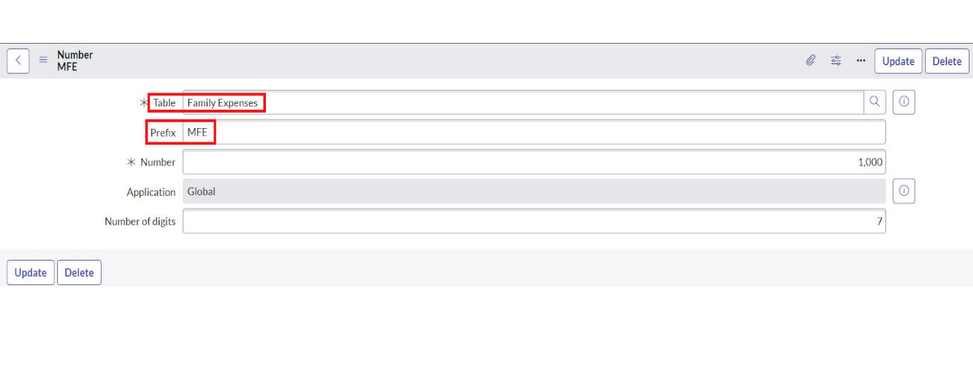
- Click on Submit.
Configure the Form
- Go to All >> In the filter search for Family Expenses >> Open Family Expenses
- Click on New
- Go to the Header and right click there>> click on Configure >> Select Form Design
- Customize or Drag Drop the form as per your requirement.
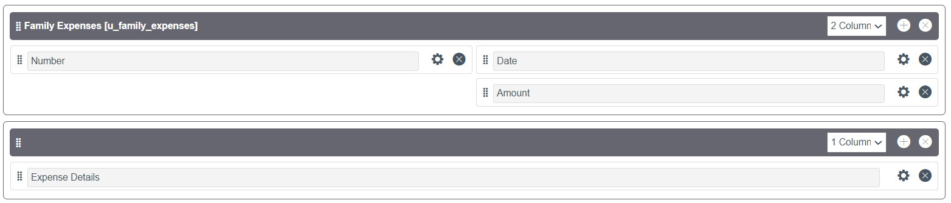
- Make Number Read-Only Field by clicking on the gear icon and checking Read-Only
- Make Date, Amount Mandatory Field by clicking on the gear icon and checking Mandatory
- Click on Save.
Creation of Daily Expenses Table
- Go to All > In the filter search for Tables > click on New.
- Enter the Details:
Label : Daily Expenses
Name : Auto-Populated
Add Module to menu : Family Expenditure
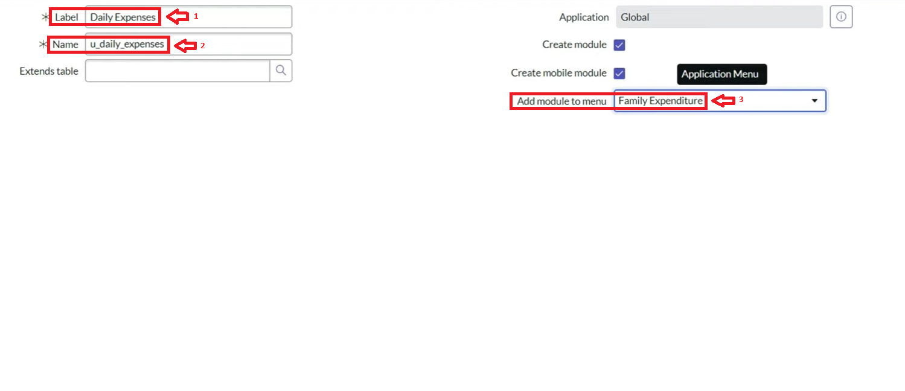
- Go to the Header and right click there>> click on Save.
Creation of Columns(Fields)
- Near Columns Double click near insert a new row.
- Give the details as:
Column label : Number
Type : String
- Double click on insert a new row again
- Give the details as:
Column label : Date
Type : Date
- Double click on insert a new row again
- Give the details as:
Column label : Expense
Type : Integer
- Double click on insert a new row again
- Give the details as:
Column label : Family Member Name
Type : Reference
Max length : 800
- Double click on insert a new row again
- Give the details as:
Column label : Comments
Type : String
Max length : 800

- Go to the Header and right click there>> click on Save.
Making Number Field an Auto-Number
- Double click on the Number Field/Column.
- Go down and double click on Advanced view
- In Default Value:
Use dynamic default : check the box
Dynamic default value : Get Next Padded Number
- Click on Update.
- 
- Go to All >> In the filter search for Number Maintenance >> select Number Maintenance
- Click on New.
- Enter the below Details:
Table: Family Expenses
Prefix: MFE
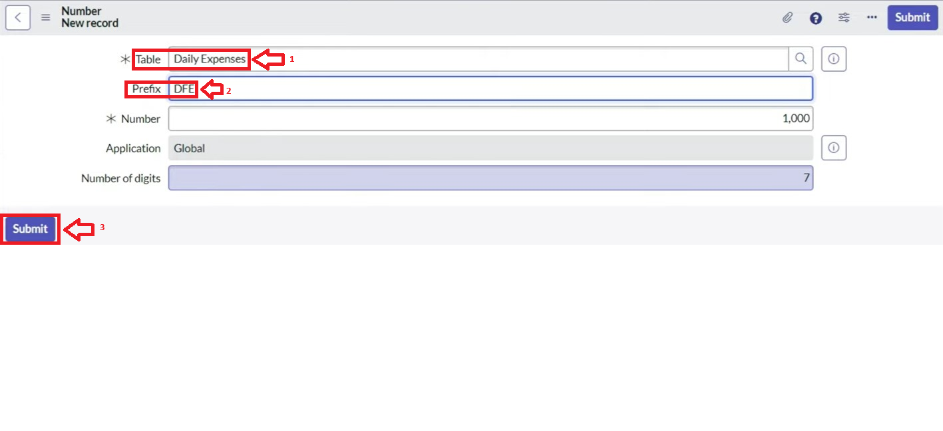
- Click on Submit.
Configure the Form
- Go to All >> In the filter search for Daily Expenses >> Open Daily Expenses
- Click on New
- Go to the Header and right click there>> click on Configure >> Select Form Design
- Customize or Drag Drop the form as per your requirement.
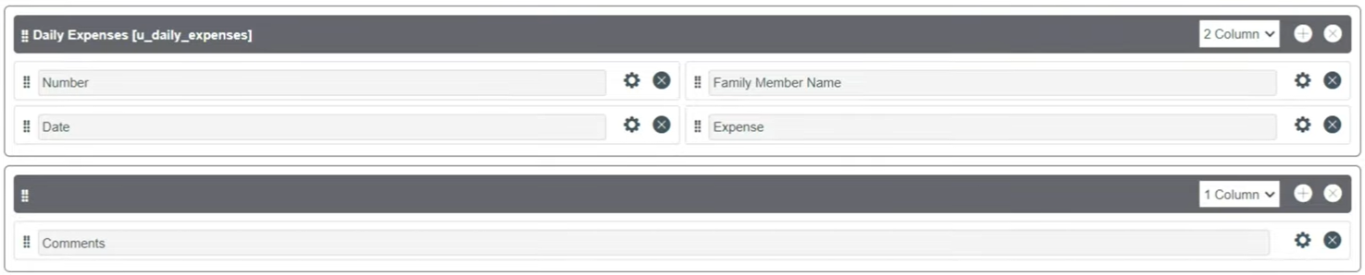
- Make Number Read-Only Field by clicking on the gear icon and checking Read-Only
- Make Date, Family Member Name Mandatory Field by clicking on the gear icon and checking Mandatory
- Click on Save.
Creation of Relationship between Family Expenses and Daily Expenses tables
- Go to All >> In the filter search for Relationships >> Open Relationships
- Click on New.
- Enter the details:
Name: Daily Expenses
Applies to table: Select Family Expenses
Daily Expenses: Select Daily Expenses
- Click Save.
Configuring Related List on Family Expenses
- Go to All >> In the filter search for Family Expenses >> Open Family Expenses
- Click on New
- Go to the Header and right click there>> click on Configure >> Select Related Lists
- Add Daily Expenses to the Selected Area.
- Click on Save
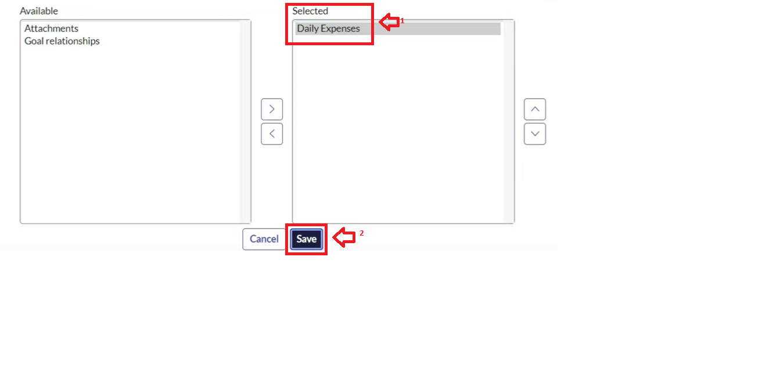
Creation of Business Rules
- Go to All >> In the filter search for Business Rules.
- Under System Definition Select Business Rules then click on New.
- Enter the Details:
Name: Family Expenses BR
Table: Select Daily Expenses
Check Advanced
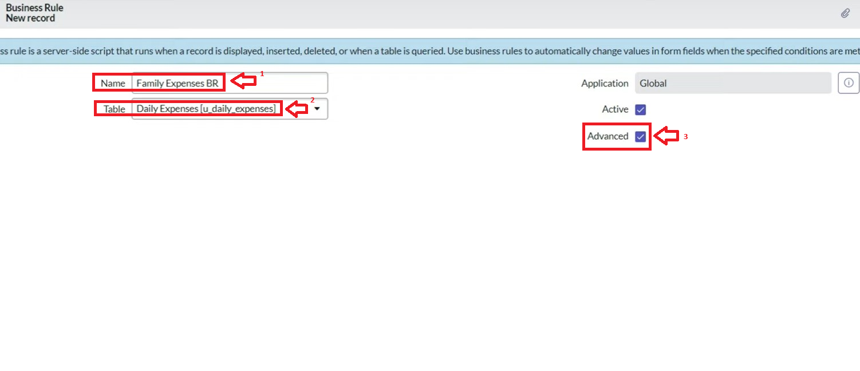
- In when to run Check Insert and Update
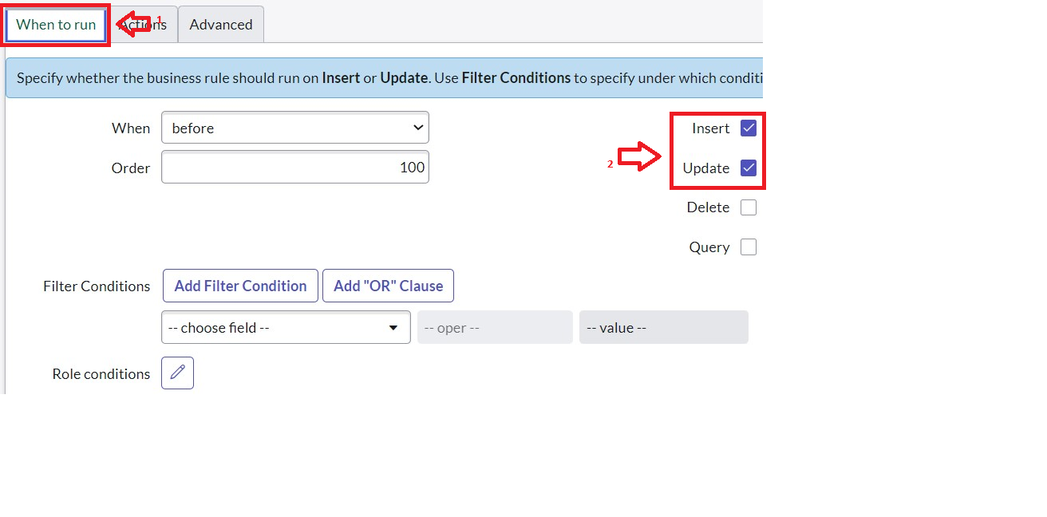
- In Advance(we write the code): Write the below code >>

(function executeRule(current, previous /*null when async*/) {

var FamilyExpenses = new GlideRecord('u_family_expenses');
FamilyExpenses.addQuery('u_date',current.u_date);
FamilyExpenses.query();
if(FamilyExpenses.next())
{
FamilyExpenses.u_amount += current.u_expense;
FamilyExpenses.u_expense_details += ">"+current.u_comments+":"+"Rs."+current.u_expense+"/-";
FamilyExpenses.update();
}
else
{
var NewFamilyExpenses = new GlideRecord('u_family_expenses');
NewFamilyExpenses.u_date = current.u_date;
NewFamilyExpenses.u_amount = current.u_expense;
NewFamilyExpenses.u_expense_details += ">"+current.u_comments+":"+"Rs."+current.u_expense+"/-";
NewFamilyExpenses.insert();
}

})(current, previous);

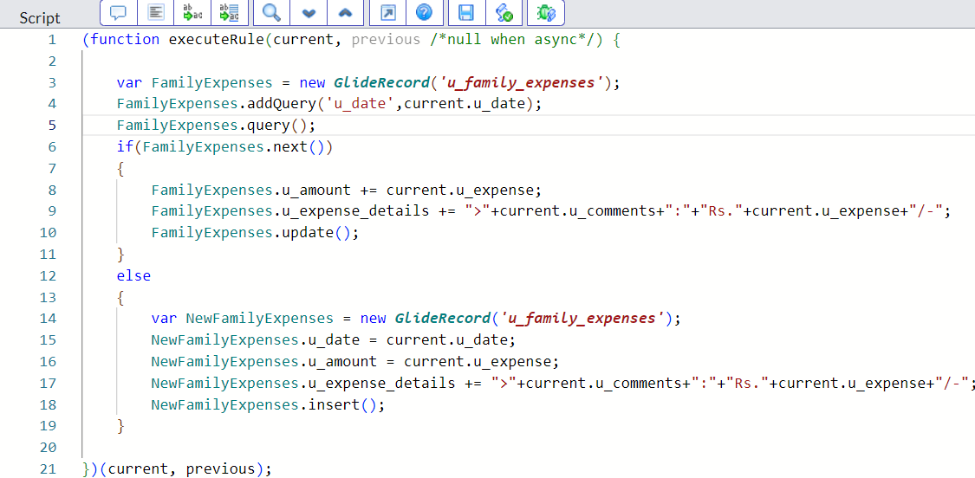

- Go to the Header and right click there>> click on Save.
Configure the Relationship
- Go to All >> In the filter search for Relationships >> Open Relationships.
- In that, open Daily Expenses Relationship.
- For Applies to table : Select Family Expenses.
- In Query with : write the below Query.

(function refineQuery(current, parent) {

// Add your code here, such as current.addQuery(field, value);
current.addQuery('u_date',parent.u_date);
current.query();

})(current, parent);

- Click on Update.

